|  |
| --- |
| User Manual  Samuda Commercial |
| REFERENCE: GW/ERP/USER MANUAL |
|  |
| **Genweb2 Ltd.** |
| **11-Apr-18** |



|  |
| --- |
|  |

# Document Information

|  |  |
| --- | --- |
| Document Name | User manual for Commercial |
| Document Author | Rashedul Alam |
| Document Version | 1.0 |
| Release Date | 11th t April, 2018 |

|  |  |
| --- | --- |
| Review by | Md. Matiar Rahman |
| Review Date | 12th April, 2018 |
| Approved By |  |
| Approval Date |  |

# Document History

|  |  |  |  |  |  |
| --- | --- | --- | --- | --- | --- |
| A=Added, M=Modified, D=Delete | | | | | |
| **Version No** | **Date** | **Section No** | **A/M/D** | **Description of Change** | **Author** |
| 1.0 | 11-April-2017 |  | A | Initial | Rashedul Alam |
| 1.1 |  |  | A |  |  |
|  |  |  |  |  |  |

Contents

A. Document Information 2

B. Document History 2

1. Introduction 4

1.1 Purpose of User manual 4

2. Import LC (local) 4

2.1 Create import LC (local) by Commercial user/Manager 4

2.2 Confirm import LC (local) by Commercial user/Manager 5

2.3 Create Shipment by Commercial User/Manager 6

2.4 Create On board by Commercial User/Manager 6

2.5 Create Receive doc by Commercial user/Manager 7

2.6 Confirm Send To & CF by Commercial User/Manager 9

2.7 Confirm ETA by Commercial user/Manager 10

2.8 Confirm C&F quotation by Commercial user/Manager 11

2.9 Confirm C&F clear by Commercial Manager 12

# 

# 1. **Introduction**

The purposes of this User manual is to clearly identify the customer requirements and provide a detailed document. The customer will read this document and get a clear view the sales module. It will also help the review team to validate whether the customer requirements have been fulfilled or not.

## Purpose of User manual

This document is the User Manual of Commercial. It is intended to provide all the necessary information to use this software to develop application software running on the workstation.

# 2. Import LC (local)

## 2.1 Create import LC (local) by Commercial user/Manager

Import LC (local) will be created/Edit by Commercial user

Commercial user can create Import LC (local) using the menu **Commercial ‣ Letter of Credit** and click **Create.**

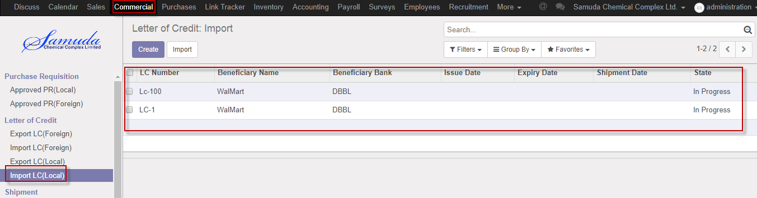

Figure: Import LC(local) List view

We need to set the following:-

**Purchase order**: Select purchase order.

**Description:** Enter description.

**Applicant candidate:** Select applicant candidate.

**Applicant bank:** Select applicant bank.

**Beneficiary candidate:** Select beneficiary candidate.

**Beneficiary Bank:** Select beneficiary bank**.**

**LC value:** Enter LC value**.**

After entering all information click **Save & Open**.

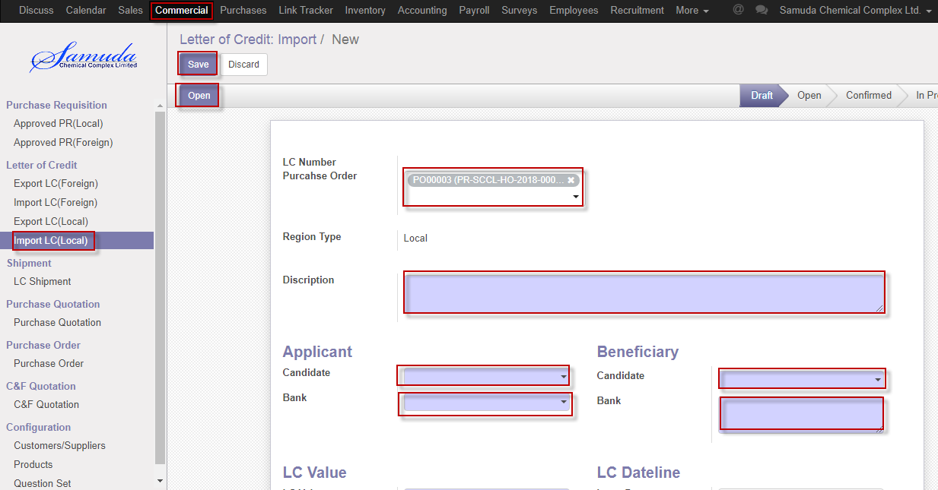

Figure: Create Import LC (local)

## 2.2 Confirm import LC (local) by Commercial user/Manager

Import LC (local) will be Confirm by Commercial user or Manager Click **Confirm** button

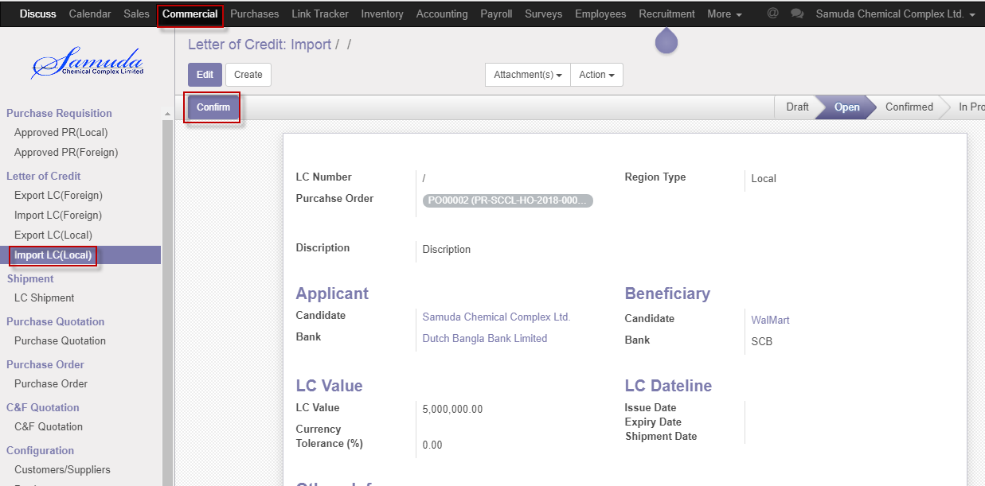

Figure: Import LC (local) Confirm

After click confirm button below window will open & will enter LC number then **Save**

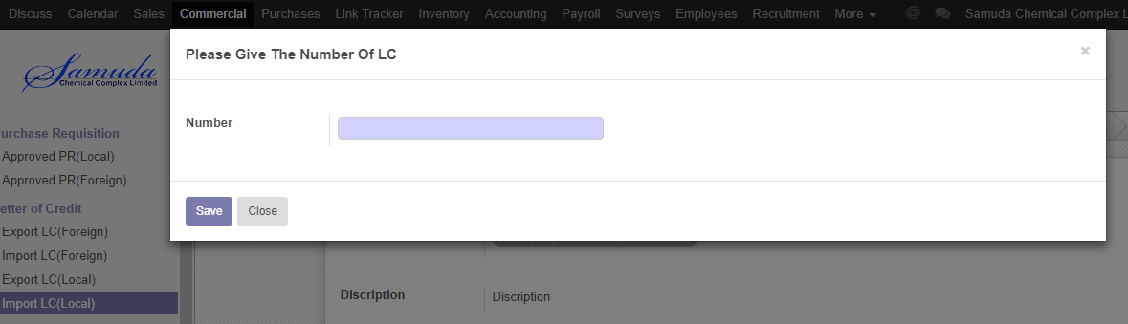

Figure: LC number window

## 2.3 Create Shipment by Commercial User/Manager

Shipment will be Confirm by Commercial user/Manager click **Shipment** button

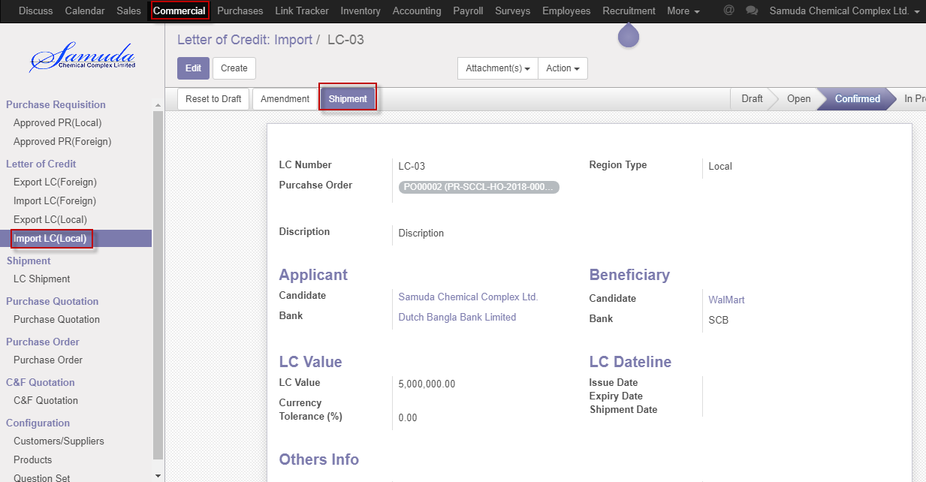

Figure: Create shipment

## 2.4 Create On board by Commercial User/Manager

On board will be Confirm by Commercial user/Manger click **On board** button

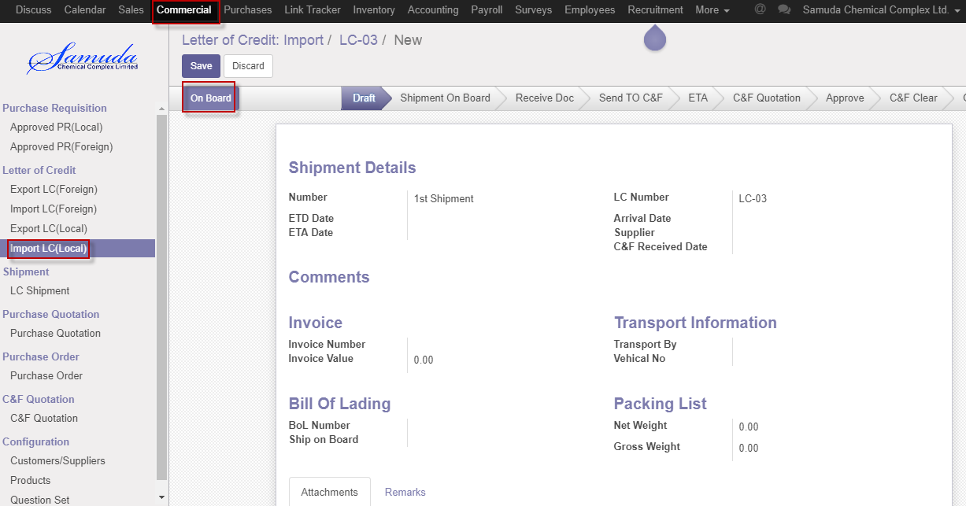

Figure: Create On board

After click On board button below window will open & will enter ETD date then **Save**

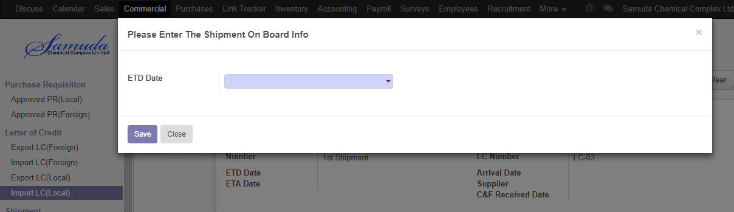

Figure: ETD date window

## 2.5 Create Receive doc by Commercial user/Manager

Receive doc will be created by Commercial user/Manager click **Receive doc** button

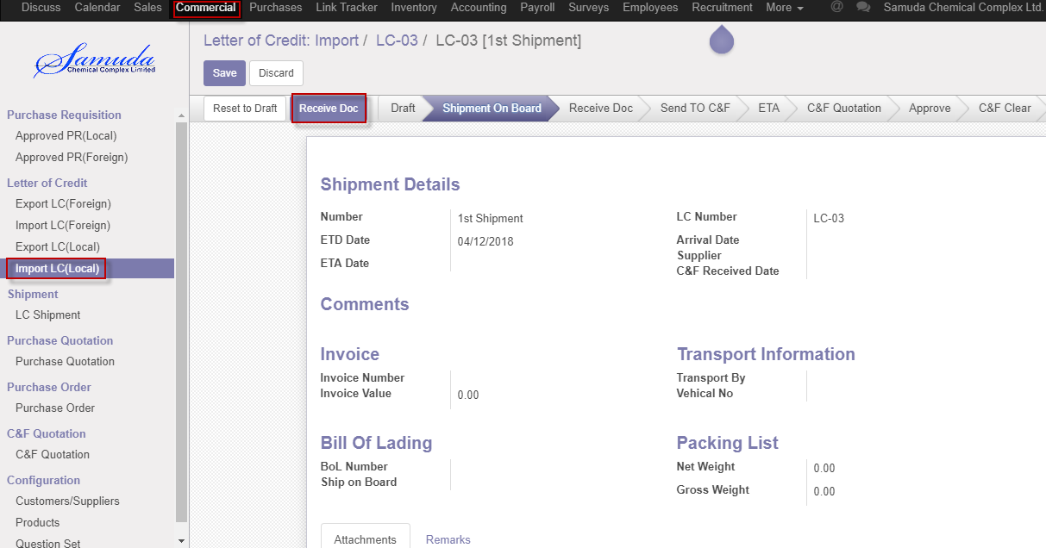

Figure: Create Receive doc

After click Receive doc button below window will open 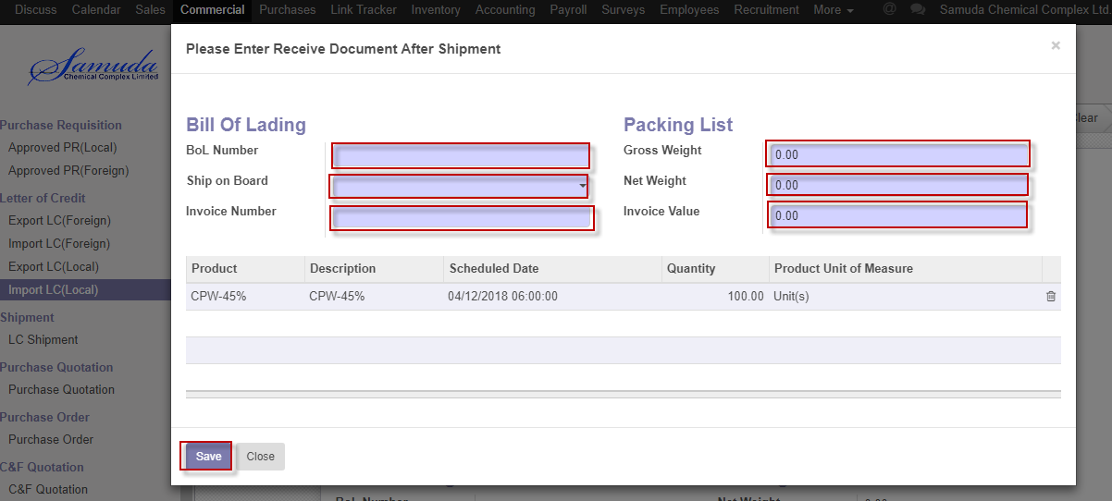

Figure: Receive doc after window

We need to set the following:-

**BoL number**: Enter BoL number.

**Ship on board**: Select ship on board.

**Invoice number**: Enter invoice number.

**Gross weight**: Enter gross weight.

**Net weight:** Enter net weight.

**Invoice value**: Enter invoice value.

After entering all information click **Save**.

## 2.6 Confirm Send To & CF by Commercial User/Manager

Send TO & CF will be created by Commercial User/Manager click **Send To & CF** button

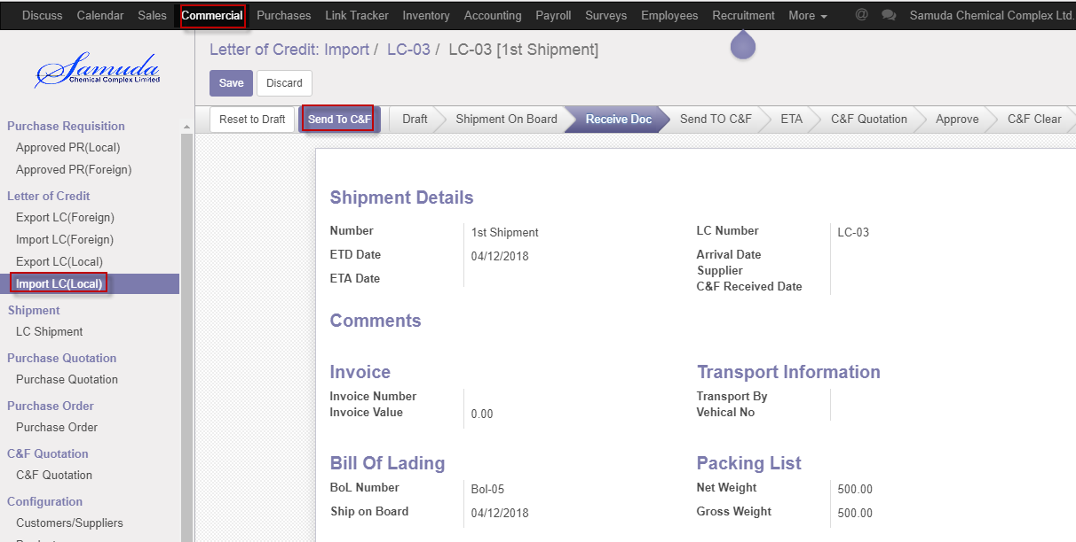

Figure: Confirm Send To & CF

After click Send To & CF button below window will open 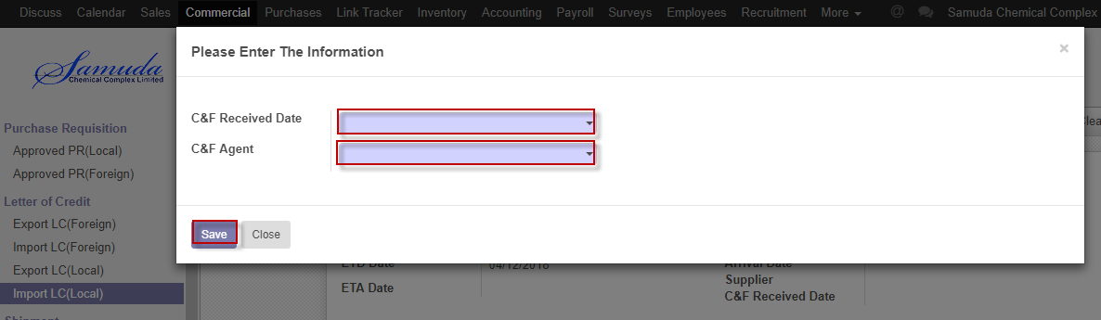

Figure: Send To & CF after window

We need to set the following:-

**C&F Received date**: Select C&F received date.

**C&F agent**: Select C&F agent

After entering all information click **Save**.

## 2.7 Confirm ETA by Commercial user/Manager

Send TO & CF will be created by Commercial user/Manager click **Send To & CF** button

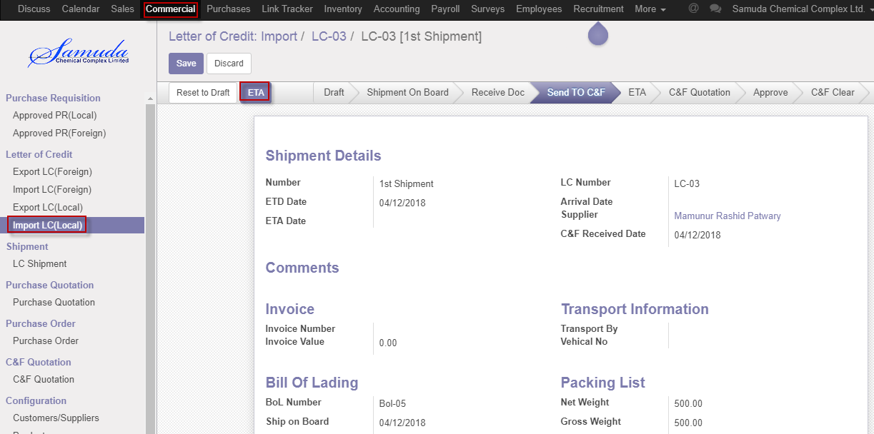

Figure: Confirm ETA

After click ETA button below window will open 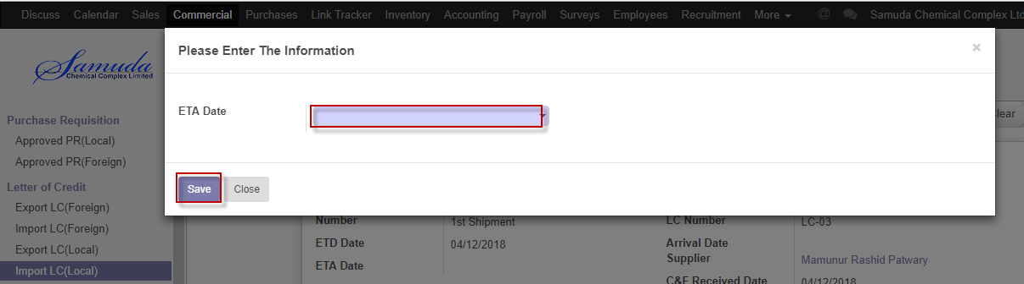

Figure: ETA after window

We need to set the following:-

**ETA date**: Select ETA date.

After entering all information click **Save**

## 2.8 Confirm C&F quotation by Commercial user/Manager

C&F quotation will be created by Commercial user/Manager by click **C&F quotation** button

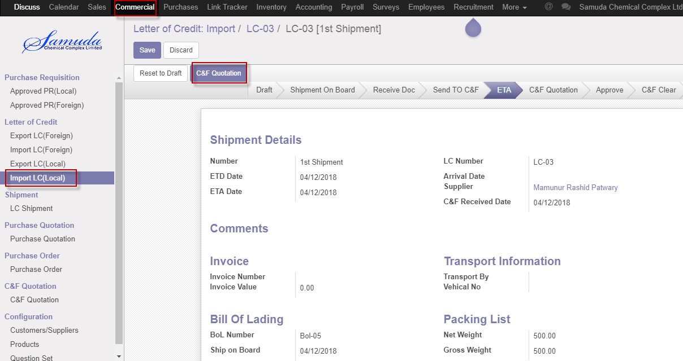

Figure: Confirm C&F quotation

After click C&F quotation button below window will open then confirm order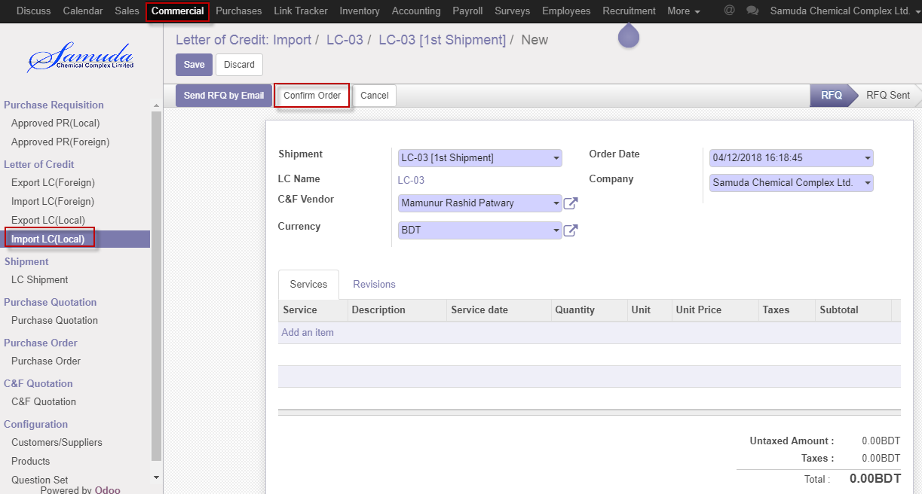

Figure: Confirm order

## 2.9 Confirm C&F clear by Commercial Manager

C&F clear will be created by Commercial Manager click **C&F** button

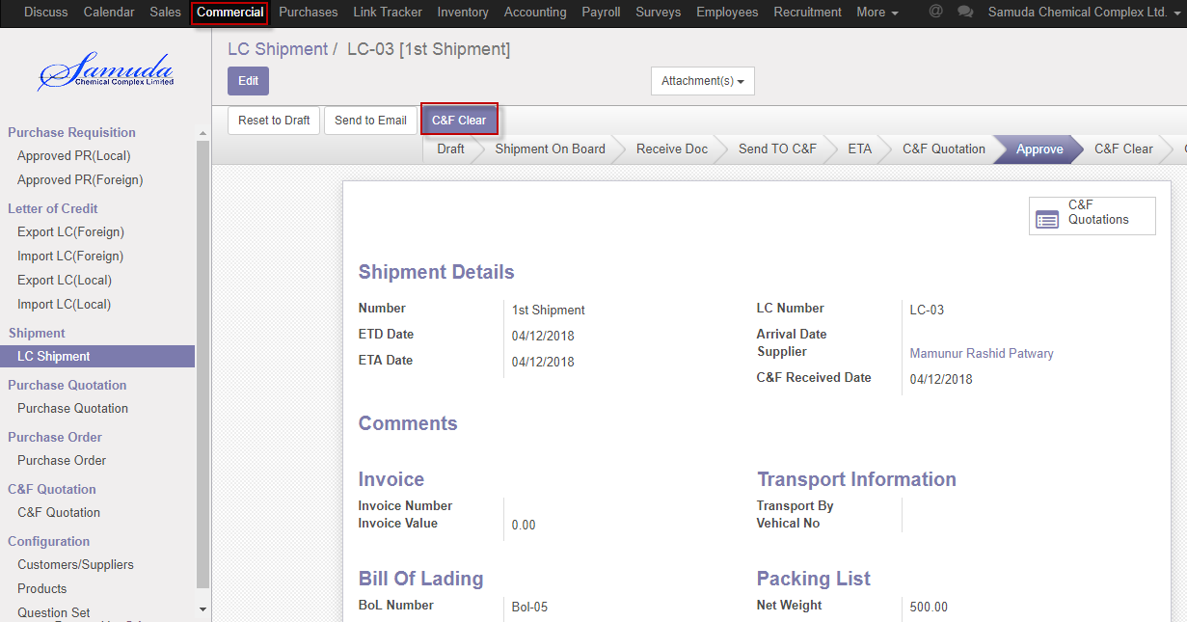

Figure: Confirm C&F clear

After click C&F clear button below window will open 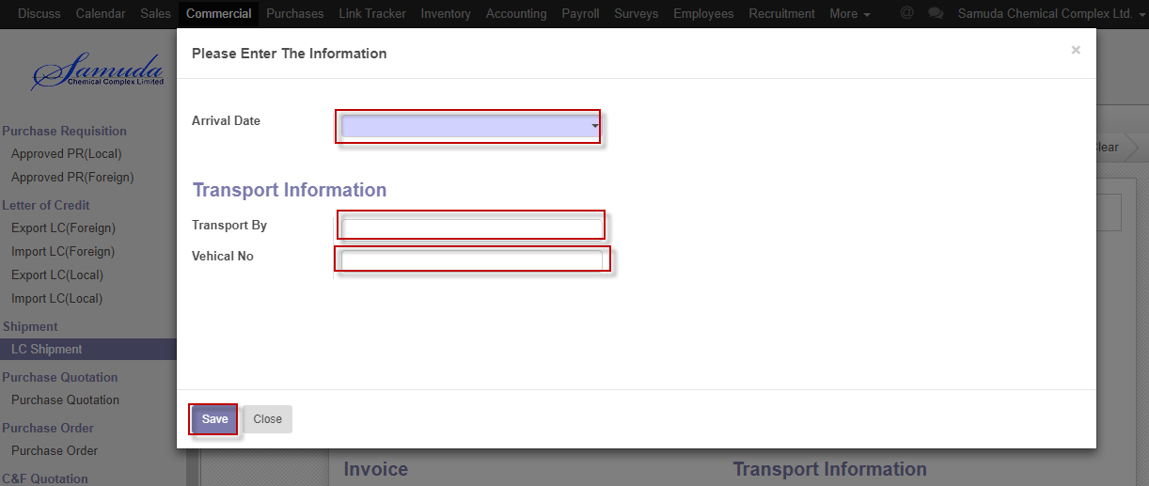

Figure: C&F clear after window

We need to set the following:-

**Arrival date**: Select arrival date.

**Transferred By**: Enter transferred by

**Vehicle No**: Enter vehicle no

After entering all information click **Save**